In this second lesson we are going to learn how to make the cat sprite walk through animation and programming. Just like the first lesson where you animated the cat and made it walk using the keyboard in this lesson you will animate the cat but use programming to make it walk around the screen.
Blocks to use | Instructions
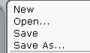 | - Open up a new project from the file menu.  Save your file straight away in your personal folder.  Call the file WalkingCat
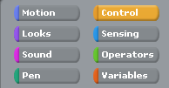 | - Click on the control icon to select the control block pallete.
 | - Drag and drop a when clicked block to the script area.
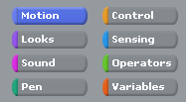 | - Click on the Motion icon to select the motion blocks pallete.
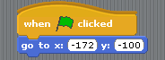 | - Drag and drop a go to x: y: block and connect it to the when clicked control.  Set the coordinates to the bottom left of the stage.  Click on the to test and adjust the coordinates if you need to.
- We now have to get the cat pointing in the right direction.
Go to the motion block pallete and drag a point in direction block onto your script.
Click on the white box to select the drop down menu then select RIGHT.

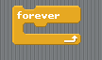 | - We now have to animate the cat so that it looks like it is walking and we use a LOOP to do this. This means the programme will keep going round in a loop until you tell it to stop.  For this we use the FOREVER loop.  Go to control and drag the forever loop onto your script.
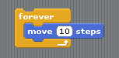 | - We now have to add blocks inside the forever loop to animate the cat.  First we need to get it to move by adding a motion block – move 10 steps – and putting it inside the forever loop.
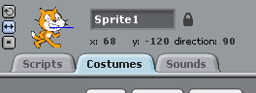 | - To animate the cat we now have to change how it looks by changing its costume.  If you click on the Costumes tab you will see the cat has two costumes.
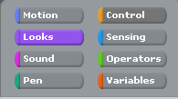 | - Click back on the scripts tab and click on the looks icon.  From the block pallete drag the block into the forever loop.
- We now have to use a timer so that the animation works over a period of time.
From the controls block pallete drag the wait control into the forever loop and set the time to 0.1 seconds.
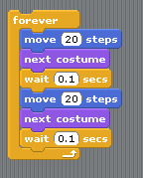 | - In order to complete the animation we have to switch back to the original costume.  To do this we add another move 10 steps block, a next costume block and a wait block.  Your forever loop should now look like the script on the left.  Now click on the to test your programme.  Try increasing and decreasing the number of steps to see what happens to your programme.
 | You may have noticed that the cat walks straight off the stage and disappears. To fix this we have to add some new sprites and then add some code blocks to your programme.
- First we have to create our own sprites.
Click on the paint new sprite button and a paint editor window will appear.

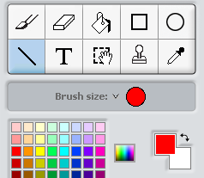 | - In the paint editor select the line tool.  Change the brush size to the third largest brush.  Select a dark colour of your choice.  Draw a line along the top of the stage.  Click OK and a new sprite will appear in the sprite list.
- You will now have to adjust the sprite by right clicking on it in the stage area and selecting resize.
Click and drag 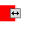the arrows to make the sprite the full size of the stage.
Move it up to the top of the stage.
It doesn’t matter if it is too big as the parts of the screen will be hidden.
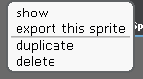 | - Right click on the sprite in the sprite list and select duplicate.  Do this two more times until you have 4 sprites.  Move one of the sprites to the bottom of the screen.
- Right click on one of the remaining sprites in the stage and select rotate this sprite.
Click and drag the until the sprite is vertical. Move the sprite to the left.
Do this with the remaining sprite and move it to the right.
You should now have a coloured square around the stage.

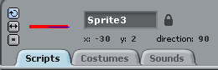 | - To use these sprites you will have to name them.  Double Click on the top sprite on the stage.  In the sprite info area, click on the sprite name and rename it top.  Rename the other sprites bottom, right and left.
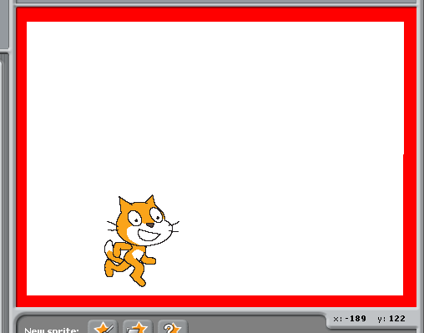 | You should now have a stage that looks like the image on the left although your walls may be a different colour.
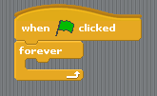 | We now have to use another forever loop so that the programme is always checking to see if the cat is touching one of the sides.  - Add a new when clicked control and a forever loop below the script for making the cat walk.
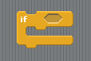 | - Inside the forever loop we have to check for certain conditions and if they are true we will tell the cat to do something.  To do this we use an IF statement.  An if statement asks a question. “If” this is happening then do this.
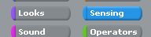  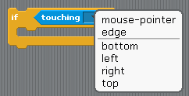 | - We now add the question to the if statement and it goes inside the shaded hexagon area.  From the sensing block pallete select – The touching question.  In the drop down box select the right sprite.  Add another three IF blocks inside the forever loop and add a touching question to each if block.
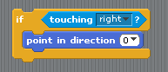  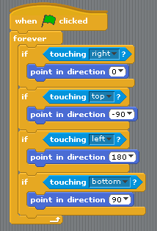 | - We now have to tell the cat what to do if it is touching one of the walls.  To do this we will add a point in direction block from the motions pallete and place it inside the if block.  If the cat is touching the right wall we want to make it climb up the wall by pointing up.  From the drop down menu select up.  Add a point in direction block to each if statement.  If the cat is touching the top wall we want it to point left.  If the cat is touching the right wall we want it to point down.  If the cat is touching the bottom wall we want it to point right.  Your script should now look like this.
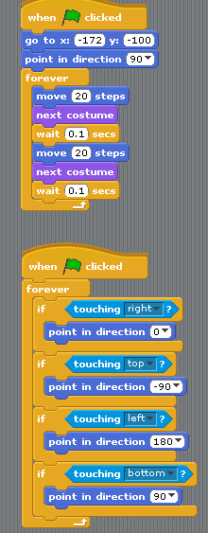  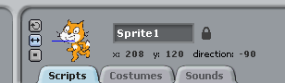 | - Check that all your script looks like the image on the left.  If it’s ok click on the green flag above the stage to test your programme.  The cat should walk all the way around the stage until you stop it.  In the sprite info panel change the rotation of the sprite to see what happens.  Click on the green flag each time to test your programme.

