In this lesson we will add a score and alter the program so that when the fish is eaten it adds to the score. We also add a poisonous fish that makes the shark sick and lose points.
Remember to follow the instructions carefully.
Blocks to use | Instructions
 | - Open your game from the previous lesson.
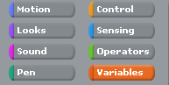 | - We will need a variable for the score.  A variable is something the program can change and can be used in different parts of the program.  Go to the variable palette.
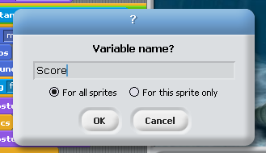 | - Click on make a variable and a dialog box will appear.  Call this variable score and make sure the button for all sprites is checked.  Click OK.  Some new blocks will appear in the variables palette and Score will appear at the top of the stage.
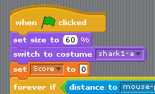 | - Click on the shark sprite and drag a set score to 0 block into your script.  Put it near the top just below the switch costume block.  This will set the score to 0 every time the game starts.
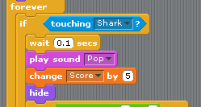 | - Click back on the fish1 sprite.  From the variables palette drag a change score by 1 block.  You need to place it after the play sound block in the if touching shark statement.  Change the score to another value of your choice.  Test your game to see if the score changes when the fish is eaten.
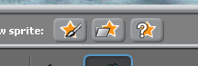 | - That is the script complete for the fish.  Now add another fish by clicking on choose new sprite from file.  Go to the nature file and choose another fish.  Name this sprite fish2.
- Now the easy part.
- Click on fish1 in the sprite list.
- Go to the script area and right click on the script and select duplicate.
You will now have a copy of all the script for fish 1.
If you move the mouse the script will move as well.
- Drag it over fish2 in the sprite area and a white box will appear around the sprite.
- Click the sprite and the script will disappear.
- Now click on fish2 and all the script from fish1 will be here.
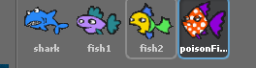  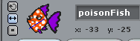 | - Now to add a poisonous fish.  Repeat steps 6 and 7 above and select the spotty fish from the file.  Rename the fish poisonFish.  If you don’t want the fish to swim upside down set the rotate button to face only left or right.
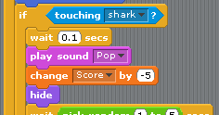 | - As the poisonous fish is not good to eat the player will lose points if they eat it.  Change the value in the change score block for this sprite and make it a negative number.
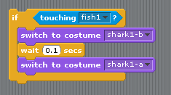 | - If you test your game you will notice that the shark only chomps on fish1 but the other 2 fish disappear.  We need to add some more script to the shark sprite.  Click on the shark sprite to select it.  Drag out the if touching shark block, right click on it and duplicate it.  Duplicate it again so that you have 3 copies.  Put all the blocks back one under the other.  Now all you need to do is select the drop down menu in the 2 copies and select fish2 and poisonFish.
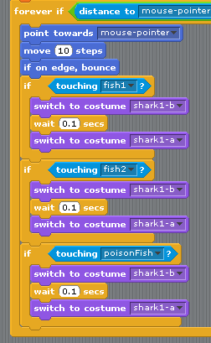 | - Your blocks will now look like this.  Make sure you attach the blocks on top of each other and not inside each other or the program will not work.  Test your game to see if the shark chomps all the fish.
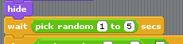 | - Click the poisonFish to select it.  So that the poisonous fish doesn’t appear as often as the other fish change the time it takes to from 1 to 5 (3 to 15).
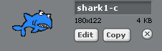 | - We can now add more animation to the shark so that it looks sick and sinks when it eats the poisonous fish.  We now have to add a new costume to the shark.  Click on the shark and go to the costumes tab.  On shark1-a costume click copy and rename the copy shark 1-c
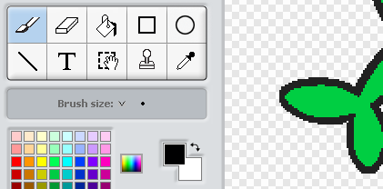 | - Now click on the edit button to open the sprite in the paint editor.  Click on the bucket fill tool and select a different colour from the blue shark.  Click on the main part of the shark to change its colour then click ok.
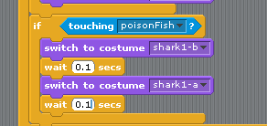 | - Go to the sprite area for the shark.  Now we will add more timers and costume changes to the shark animation.  Click on the control palette and select a wait 1 sec block.  Find the if touching poison fish block and add the wait block below the costume change block.  Change the time to 0.1 secs
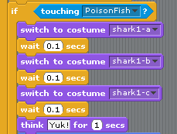 | - Next add a switch to costume block below the wait block and select shark 1-c from the drop down menu.  - Add another wait 0.1 sec block  - Go to looks palette and add a think – for 1 sec.  In the white box add a work the shark would think if it ate something horrible.
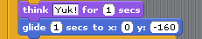 | - To get the shark to sink we add a glide block.  Go to the motions palette and select a glide 1 sec to x: y:  Set x to 0 (the centre of the stage)  Set y to -160 (the bottom of the stage)
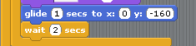 | - Add another wait block but this time choose a time between 1-3 seconds.  This will mean the shark can’t move until the timer has finished.
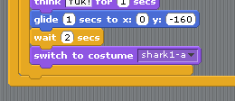 | - To finish add a switch to costume block and select shark 1-a from the drop down menu.  This will change the shark back to the blue colour.  If you want to you can add a sound when the shark eats the poison fish.  You will need to import the sound and add a play sound block after you switch to costume 1-c.
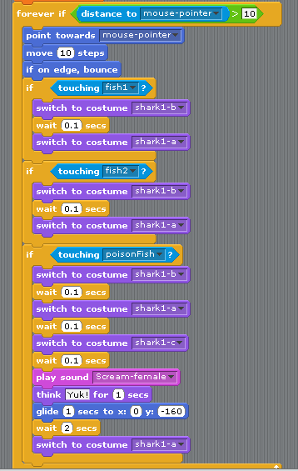 | - Your finished shark script should now look like this.  *Extension  Try adding another fish it could be one you have already used just change the colour.  You will need to add an animation block to the shark sprite as you have done above.  This could be a bonus fish that doesn’t appear often but is worth lots of points.  What values will you change in this new sprite to achieve this. Try and work it out.  In the next lesson we will add a baddy and lose lives if the shark is eaten.

