In this lesson we will be adding a baddy that can eat your shark sprite. When this happens the player will lose a life. We will program the game to end if all the lives are lost. We will add more variables and use coordinates again to move the baddy.

Blocks to use | Instructions
 | - Open your game from the previous lesson.
- Go to the choose new sprite from file and add shark 1-a from the animals file.
- Click on the costumes tab and then import. Import shark 1-b to costumes.

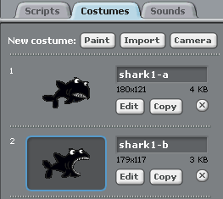 | - Click edit on shark 1-a.  In the paint screen select the bucket fill tool and select the black colour.  Colour your shark black by clicking on it.  Click OK.  - Click edit on shark 1-b and do the same as above
- Click back on the scripts tab and add a when clicked block.
- Keep the shark the same size.
- Add a hide block so that the shark does not appear when the game starts.

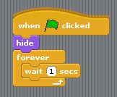 | - We will use a forever loop again so that the program for the shark runs the whole time.  Add a forever loop.  Inside the forever loop add a wait 1 sec block.
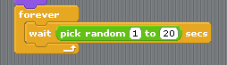 | - Again we want the shark to appear randomly so we need to put a pick random block inside the wait block and set the time ( 1 to 20 secs).
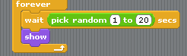 | - Add a show block from the looks panel to make it appear.
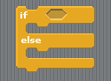 | - Now we will make the sprite move and animate it.  Depending on what side it appears we have to program it to move left or right.  For this we us an if else statement again.  If it appears on the right – move left.  If it appears on the left – move right.  We don’t want it to go in a straight line so we will need to use random values again.
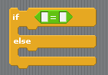 | - Connect the if else statement to the show block.  - Go to operators palette and drag an = operator into the if statement.
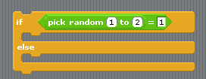 | - Now drag a pick random block into the first white box.  Set the values 1 to 2 = 1.  If the computer picks 1 we will program the sprite to appear from the right.  If it picks 2 we will program the sprite to appear from the left.
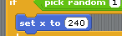 | - To make the sprite appear from the left add a set X: to block and set the value to 240 (the right of the stage).
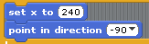 | - Now we need to point the sprite to the left by adding a point in direction block and setting this to left.
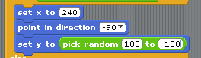 | - We want it to appear somewhere along the left of the stage so we will pick a random point on the Y-axis (vertical).  Add a set Y to block and then add a pick random block inside the white box.  Set the values to 180 (top) and -180 (bottom)
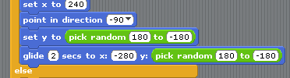 | - To make the shark move across the screen add a glide to x: y: block.  So that it doesn’t swim straight across the stage we will choose another random point on the Y-axis.  Add a pick random block and place this inside the Y coordinate box.  Set the X coordinate to -280 (off the left of the stage).
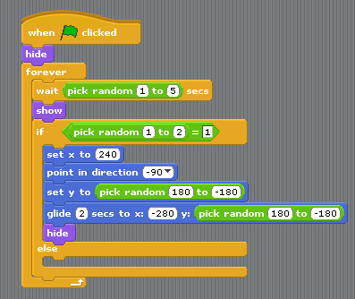 | - To hide the shark, add a hide block at the end.  Your script should now look like this.  - All the values in 19 can be adjusted to make the sprite swim faster or only appear in a certain area.  Try this later and see what happens.  If you test the game now the shark will swim across the stage but its tail will still stick out.  Tip – if you test the game change the time it takes the shark to appear from 20 seconds to 5 seconds.
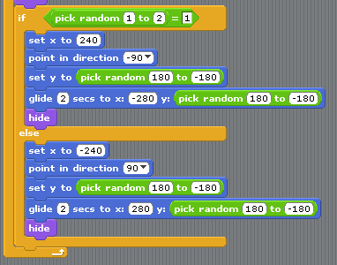 | - Drag out the script that’s inside the if part of the statement .  Right click on it and select duplicate.  Now place the original back inside the if part of the statement.  Place the copy inside the else part.  Now change the values so that it comes in from the left  X: -240.  Direction = right (90).  Set x in the glide block to 280.  Your if else statement should now look like this.  Test your program.  The shark should appear randomly from the right or left.
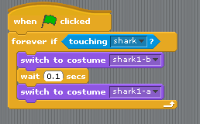 | - To animate the shark we need to use a whole new block of script so that it doesn’t conflict with the if else statement.  Animating the big shark to chomp is the same as we did for the smaller shark.  Add this block of script into your baddy’s script area.  We are using a forever if statement so that the shark is always checking if it is touching the shark.
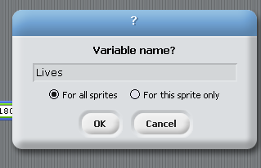 | - Before we change the players shark we have to add another variable for lives.  - Click on variables palette and click make a variable.  Call this variable Lives and make sure its checked for all sprites.  Click OK.
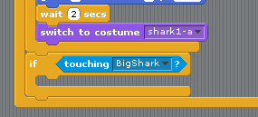 | - Now click on your smaller shark sprite (player’s).  We now need to add another if touching statement inside the forever if loop.  Add an if statement and place touching sensing block inside and set to BigShark (your name might be different).
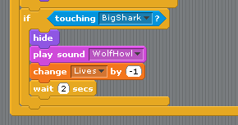 | - We now add some script blocks to make the shark disappear, play a sound, lose 1 life then wait to reappear.  - Add these blocks to your script.  You will need to import a new sound of your choice.  Set the value of change lives to -1.
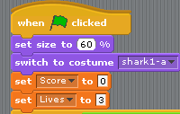 | - We will have to add another variable block at the start of the script to set the number of lives.  - Drag a set lives to block and place it below the set score block.  Change the value to 3.
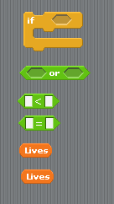 | - For this lesson to end the game we will just stop everything from working.  Make sure the small shark sprite is selected and drag an if statement into the script area but don’t attach it to anything yet.  We need to build up this statement using a lot of different blocks placed inside each other.  Firstly we will use an or operator. This allows us to check if two things are happening.  Next we will need a less than operator.  An equals operator.  2 Lives variables.  Put these in an empty area of your script area so that they are ready to put together.
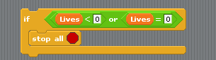 | - Drag the or operator into the hexagon of the if statement.  - Drag the less than operator into the first hexagon of the or operator.  - Drag the equals operator into second hexagon of the or operator.  - Drag a lives variable into the first white box of the less than operator.  - Drag a lives variable into the first white box of the equals operator.  - Set the value in the two empty white boxes to 0.  Your script should look like the script on the left.  We are checking to see if the lives left are less than or equal to zero.  From the control palette add a stop all block.
 | - Add this whole block to the rest of your script inside the forever if loop and just below the if touching shark statement.
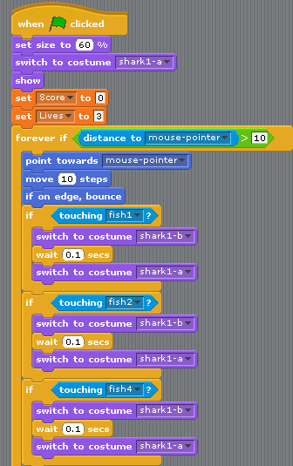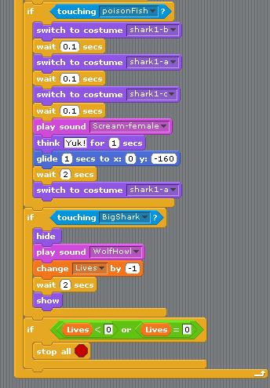 | - Your whole shark players script will now look like this.  It may look a bit complicated now but if you go through each part separately you will see each one does something different.  In the next lesson we will work with broadcasting messages.  This allows us to send a message to the sprites and tell them to do something.  If we want them all to disappear at the end of a game we can broadcast one message that all the sprites listen for and then hide when they hear it.  You game is just about finished. The next lessons are mainly based around making your game look and act like a game you would play on the internet or games console.

