In this last lesson we will add a win and lose screen to the background that will only appear when the player wins or loses. To do this we will broadcast messages that tell other parts of the program to do something when they hear it. We will set up other parts of the program to listen for these messages and these are called event listeners. We will need to change all of the when green flag clicked blocks to when I receive (message) blocks.
Blocks to use | Instructions
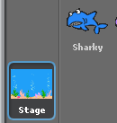  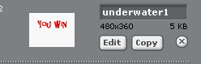  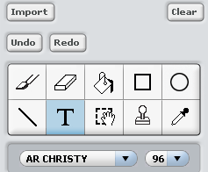 | - First of all make your win and lose screens.  Click on the stage in the sprites area and select backgrounds.  Copy the underwater background then click on edit.  Click on clear to clear the canvas.  Select the text button and write you win. Make the text large and change the colour.  If you hover over the little black square this allows you to move the text about. Move the text so that it is centred and near the top of the screen ( so there is room for a play button below it).  Do this sequence again to make a lose screen.  Remember to name the backgrounds such as win screen or lose screen
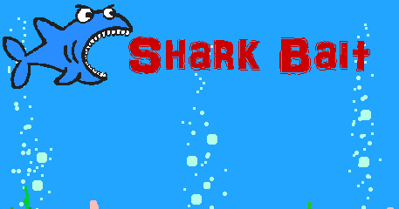 | - To make the title screen copy the underwater scene again.  Click on edit and import an image such as the shark.  Add the text of your title and edit it the way you want it.  Remember to name the background – title screen.
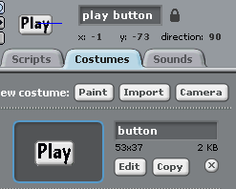 | - Now you need to add a play button.  Click on choose a new sprite from file and open the Things file.  Choose the button sprite.  You will need to make it bigger by right clicking on it and select resize.  On the costumes tab for the sprite click on the edit button to add text.  Write the word play and change its size and position until if fits inside the button.  Click ok and rename it play button.
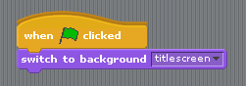 | - Click on the stage in the sprites area again and make sure you are in the scripts panel.  Add a when green flag clicked block.  Connect a switch to background block and select title screen.  If you test the game just now the title screen will appear but so will all the sprites.  You will have to tell them to hide until the game starts.  Add a broadcast block from the control blocks.  When you click on the down arrow a new dialogue box will appear. Click on this and type in hideSprites.  We now have to add an event listener to all the sprites to listen out for this message and when they hear it they hide.
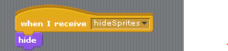 | - Click on the shark sprite and from the control blocks add a when I receive block at the top of the script.  Add a hide block below this.  Right click on this block and duplicate it. Drag a copy over to the next sprite in the sprite panel and drop it there.  Do this again for all the sprites except the play button.  You will need to go to each sprite and move the block up to the top of the script.
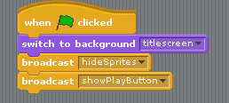  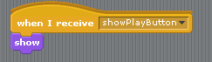 | - You want the play button to appear on the title screen so you need to add another message.  Click back on the stage and add a new message and call it show play button.  Click on the play button sprite and drag and drop a when I receive block onto the script area.  Select showPlayButton from the drop down menu and add a show block.
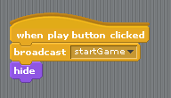 | - When the play button is clicked we want to start the game.  In the play button script panel add a when play button clicked and then add a new broadcast block.  Create a new message called startGame.  Finally to make it disappear after it has been clicked add a hide block.
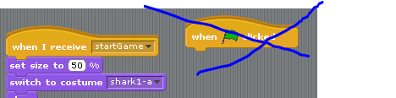 | - You now have to change all the when green flag clicked on all the sprites to a when I receive start game message.  Click on each sprite and change each green flag block to a when I receive block and make sure you select startGame from the drop down menu.
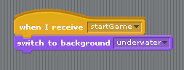 | - When the play button is clicked you want the title screen to disappear and the underwater background to appear.  Click on the stage in the sprite area.  Add a when I receive block and select startGame.  Add a switch to background block and select the underwater background.
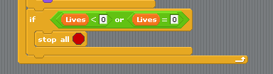  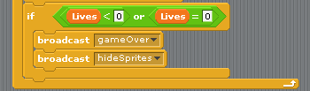 | - Now to make the lose screen appear when the player loses 3 lives.  Click on the shark sprite and remove the stop all block from the if statement at the bottom.  Replace this with a broadcast message block and name this message gameOver.  When the game is over we want all the sprites to disappear so add a broadcast hide sprites message.  The sprites are already listening for this message so you don’t need to do anything else.
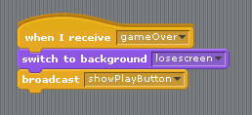 | - To make the lose screen appear click on the stage in the sprite area and add a when I receive block and set this to game over.  Add a switch background block and select loseScreen.  You want the player to be able to play again so add a broadcast message to make the play button appear on the lose screen.
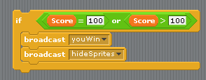  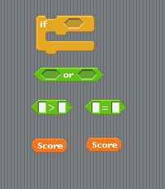  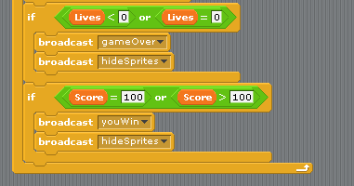 | - To win the game you can use a certain number of point won to activate the win screen.  This is done in the same way as checking how many lives are left.  Click on the shark sprite and in the script area build up and if statement using the blocks on the left.  We use an or operator because depending on how many points you get for each fish they may not add up to an exact number such as 100.  This will allow the program to check if the score = 100 or is greater than 100.  Remember to add the blocks to the or operator and then put it inside the hexagon in the if statement.  Add a new broadcast message and call it youWin.  Add a hideSprites message to hide all the sprites.  Place the if statement below the if statement for lives in the shark sprite.
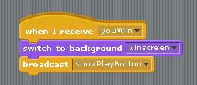 | - Making the win screen appear is just the same as the lose screen at number 11.  Remember to change the message to youWin and show the play button.
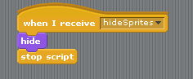 | - Now test your game. Make sure you win and lose to see if it is all working correctly.  You may see some of your sprites still appear after the game finishes. To stop this add a stop script from the control blocks to each sprite at the hideSprites script.  Try changing the values of some of your sprites to make the game harder or easier.  Change how fast the fish swim or the number of points for each fish.  Maybe you could lose a life if you eat the poisonous fish. How would you do this.  Give it a try.

