In this lesson we will begin to make our underwater game. We will add an underwater background and some new sprites to use in the game. We will also learn how we can control the main character in the game using the mouse instead of the key board.
Blocks to use | Instructions
Remember to save your work as soon as you start. | - Open up a new project by clicking on the file menu and selecting new.
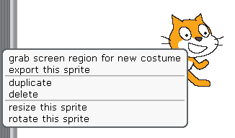 | - We are not using the cat so right click on it and select delete.
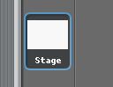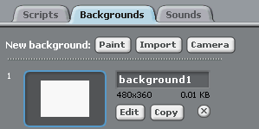 | - Click on the stage in the sprite area to select it.  - Go to the sprite info area and select Backgrounds.  - Click the import button to select a new background.  - Choose the underwater scene from the nature folder.
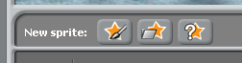  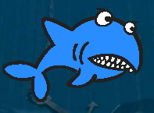 | - Now add a new sprite by clicking choose new sprite from file button.  Go to the animals file and select Shark 1a.
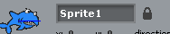 | - Go to the sprite info area and change the name to something you will remember about the sprite. E.g. sharky
 | - Now go to the control blocks and drag a When clicked block onto the script area.
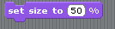 | - The shark is a little big so to change its size go to the looks block and drag a change size block over.  Change the value to 50%  Click on the green flag to see what happens.
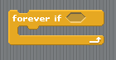 | - We now have to get the shark to follow the mouse pointer.  Just like previous lessons we will use a loop so that the program is always doing this.  This time we need to check to see how far away the shark is from the mouse pointer so we use a forever if loop.  Go to control blocks and connect a forever if loop to your script.  Remember using if means you are checking to see if something is happening and if it is you are telling the program to do something.
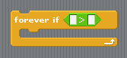 | - We now need to set the condition we are checking for.  Go to the operators blocks and drag a into the forever if loop putting it inside the hexagon.
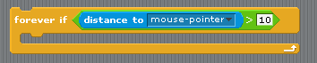 | - This means we are checking that something is more than something else.  We are going to check if the shark is more than 10 pixels away from the mouse pointer.  In the sensing blocks drag a distance to block into the first white box and select mouse pointer from the drop down menu. Set the > value to 10.
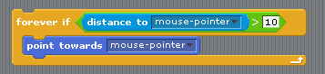 | - If the shark is more than 10 pixels away from the mouse pointer we now have to get it to move towards it.  First add a point towards block from the motions palette and put it inside the forever if loop. Select mouse-pointer from the drop down menu.
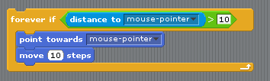 | - Now to get the shark to move we add a move 10 steps block.
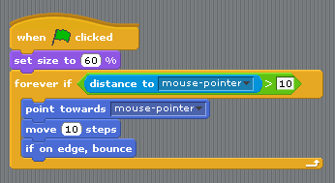  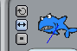 | - So that the shark doesn’t disappear off the screen we add an if on edge bounce block.  If the shark touches the edge of the stage it will turn around.  Your script should now look like this.  Click on the green flag to test.  What happens?  Try making the shark dizzy.  Try changing the value of move steps to see what happens.  Switch from rotate to face left and right in the sprite info area to see how this looks.
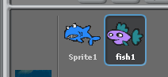 | - Now to add some food for the shark.  Go to new sprite from file and select nature. Choose a fish to use. Rename it fish1.  Click on fish1 to select it.
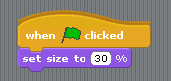 | - From the control blocks add a when clicked block.  Go to the looks blocks and add a set size to block and change the value to 30%.  This will shrink the fish.  Now add a hide block to hide the fish until we want it to appear.
- Follow the next instructions carefully.
We want the fish to appear in different places and at different times.
For the time we use a pick random command.
From the control blocks connect a wait block.
Go to the operators blocks and put an pick random block inside the white box.
Change to seconds value to 5 secs.
First we get the computer to randomly choose either 1 or 2.  If the answer is 1 then the fish appears on the left. If it is 2 the fish will appear on the right.  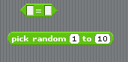  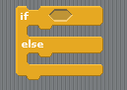  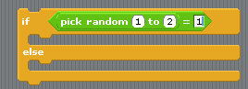 | - We now use a control where if one thing isn’t happening something else is.  For this we use an if else statement.  From control blocks add and if else statement.  From operators add an = operator inside the hexagon  From operators add a pick random block inside the first white box
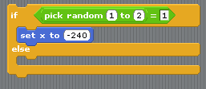 | - If the number is 1 we now tell the fish to appear from the left.  Go to motions blocks and add a set x to block inside the if else statement.  Set x to -240 which is left of the stage (horizontal axis).
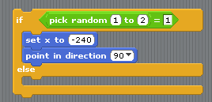 | - To get the fish to point towards the right add a point in direction block and set to right.
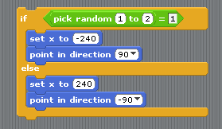 | - If the number is 2 we now tell the fish to appear from the right.  Add the same blocks as step 22 but set x value to 240 (right of the stage on the horizontal axis and set the direction to pointing left.
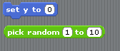  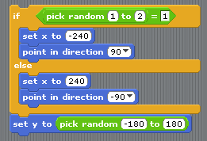 | - We now have to tell the fish where to appear on the y-axis(vertical).  As this doesn’t matter which side the fish appears on we add this below the if else statement.  For this we need a set y to motion block and a pick random operator block.  Put the pick random block inside the set y to block.  To set the coordinates change the values to -180(bottom) and 180(top).  Now we want it to appear by connecting a show block.
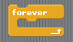 | - To get the fish moving we now have to add a forever loop and connect it below the show block.
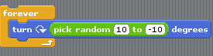 | - To get the fish to move around the stage we first have to add a turn block from the motions palette.  If we leave it like this the fish would just go round in circles.  Add a pick random block from the operators palette and place inside the white box.  Change the values to -10 and 10 degrees.
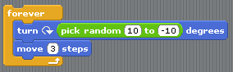 | - To get the fish to move add a move 10 steps block and change the value to 3 steps.
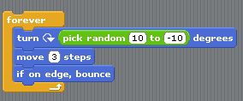 | - To keep the fish on the stage if it touches an edge it needs to bounce off it.  Add if on edge bounce block.
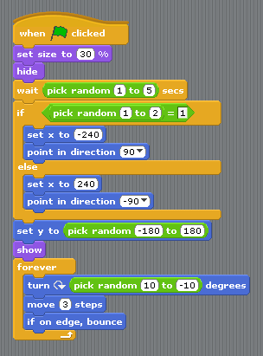 | - The complete script for your fish should now look like this.
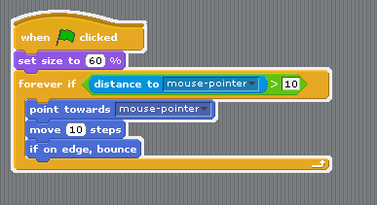 | - The complete script for your shark should look like this.  Test your game to see how it looks and everything is working properly.  Extension.  Go back and change some of the values to see what happens.  Do the changes look better?  Hint  *change the number of steps to speed up or slow down your sprite.  Remember to save your work.

