In this lesson we will program the sprites to recognise when they are touching each other. When the shark touches the fish we will animate the shark so that it will eat the fish. When the fish is eaten we will make it disappear.
Blocks to use | Instructions
 | - Open your shark program you made in lesson 3.
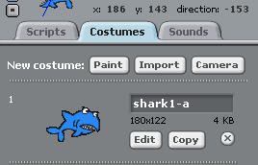 | - Click on the shark sprite and go the costume tab to import a new costume.  Click on import and select the nature file and choose shark1-b.
 | - Now click on the scripts tab to go back to the scripts panel.
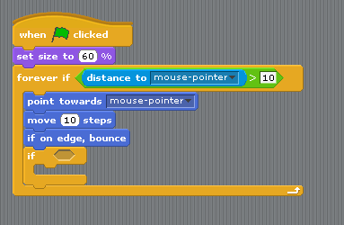 | - Inside the forever if statement we now have to add another if statement.  We will now check the whole time the program is running (forever) if the shark is touching fish1.
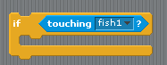 | - Inside the forever if hexagon add the sensing block touching.  In the drop down menu select fish1.
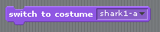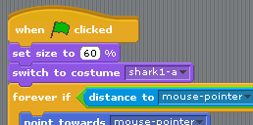 | - To animate the shark we have to change its costume.  First of all we have to make sure it always starts with the same costume.  In the looks palette select switch to costume block and place below the set size to block near the top of the script.  *Make sure the costume is set to shark1-a
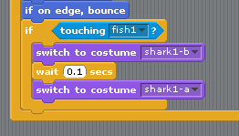 | - Inside the if loop add a switch costume block and change this to shark 1-b. Again to animate anything we need a timer so add a wait 1 sec block and change this to 0.1 secs.  Now add another switch costume block and set back to shark 1-a.  Now save your program and test.  Does your shark chomp at fish1?
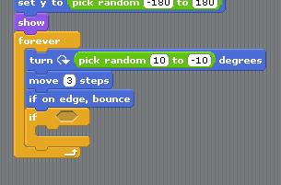 | - We now have to do something similar with the fish.  Click on the fish sprite to select it and add an if statement inside the forever loop.
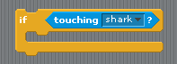 | - We now have to check if the fish is touching the shark and if it is we will play a sound and make it disappear.  Add a touching block from the sensing palette and set it to the name of your shark sprite.
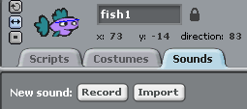 | - First we will add a sound.  Click on the sound tab and then on import.  Select the POP sound from the Effects folder.  Click on the scripts tab to go back.
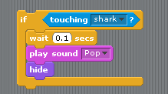 | - We will now add a timer by adding a wait 1 sec block and changing its value to 0.1 secs.  - Next add the play sound block from the sounds palette. Make sure Pop is selected.  - Then add a hide block to make the fish disappear.
 | - We want the fish to keep reappearing while the game is being played so we have to program it to show again just like we did in lesson 3.
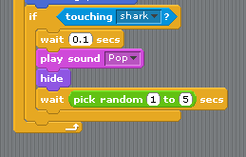 | - We will now set a random timer to make it reappear.  Under the hide block add a wait 1 sec block. Inside this add a pick random block and set this to 1 to 5 secs.
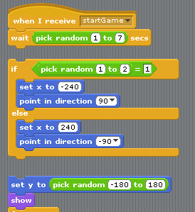 | - We can use the script we made in lesson 3 to make the fish appear randomly on the stage.  On your script pull the block apart at the if else statement.  Pull the set y to block away from the if else statement so that it looks like the script on the left.  Now right click on the if else statement and select duplicate. You now have to if else statements.  Put one over to the side and reconnect your script blocks.
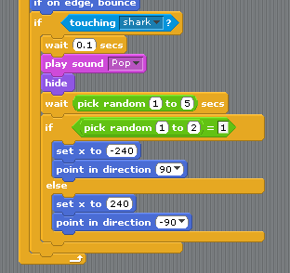 | - Now drag your extra if else statement under the wait block.
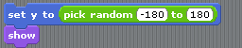 | - Pull the blocks apart at the set y position and duplicate these two blocks.  The show block will now make your fish reappear.
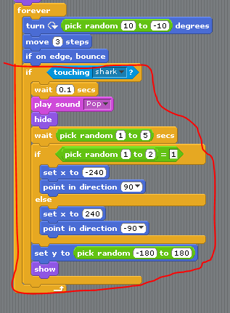 | - Place this under the if else statement. Be careful where you place this as it must be inside the if touching shark statement.
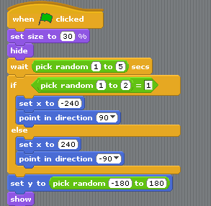  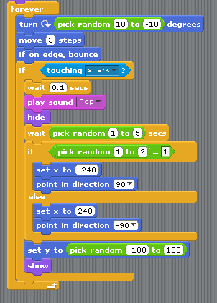 | - Your finished script for fish1 will now look like this.  It is starting to look a bit complicated but check that you have an if else statement in the top section of your script and a copy of it in the if touching shark statement in the bottom half of the script.  Now test your program.  Does the shark eat the fish?  Does the fish reappear after a little time?  It is now starting to look like a game.  This was one of the hardest parts of the game and it is now quite easy to add lots more fish.  Before we add any more fish we will need to add the score in the next lesson.

